**Experiment – 9**

**Student Name: Vivek Kumar UID: 21BCS8129**

**Branch: BE-CSE(LEET) Section/Group: WM-20BCS-616/A**

**Semester: 5th Date of Performance: 9/11/2022**

**Subject Name: Machine Learning Lab Subject Code: 20CSP-317**

**1. Aim/Overview of the practical:**

Implement Principle Component Analysis.

**2. Task to be done/ Which logistics used:**

Implement Principle Component Analysis.

**3. Steps for experiment/practical/Code:**

import numpy as np

def PCA(X , num_components):

    #Step-1

    X_meaned = X - np.mean(X , axis = 0)

    #Step-2

    cov_mat = np.cov(X_meaned , rowvar = False)

    #Step-3

    eigen_values , eigen_vectors = np.linalg.eigh(cov_mat)

    #Step-4

    sorted_index = np.argsort(eigen_values)[::-1]

    sorted_eigenvalue = eigen_values[sorted_index]

    sorted_eigenvectors = eigen_vectors[:,sorted_index]

    #Step-5

    eigenvector_subset = sorted_eigenvectors[:,0:num_components]

    #Step-6

    X_reduced = np.dot(eigenvector_subset.transpose() , X_meaned.transpose() ).transpose()

    return X_reduced

import pandas as pd

#Get the IRIS dataset

url = "https://archive.ics.uci.edu/ml/machine-learning-databases/iris/iris.data"

data = pd.read_csv(url, names=['sepal length','sepal width','petal length','petal width','target'])

#prepare the data

x = data.iloc[:,0:4]

#prepare the target

target = data.iloc[:,4]

#Applying it to PCA function

mat_reduced = PCA(x , 2)

#Creating a Pandas DataFrame of reduced Dataset

principal_df = pd.DataFrame(mat_reduced , columns = ['PC1','PC2'])

#Concat it with target variable to create a complete Dataset

principal_df = pd.concat([principal_df , pd.DataFrame(target)] , axis = 1)

import seaborn as sb

import matplotlib.pyplot as plt

plt.figure(figsize = (6,6))

sb.scatterplot(data = principal_df , x = 'PC1',y = 'PC2' , hue = 'target' , s = 60 , palette= 'icefire')

**4. Result/Output/Writing Summary:**

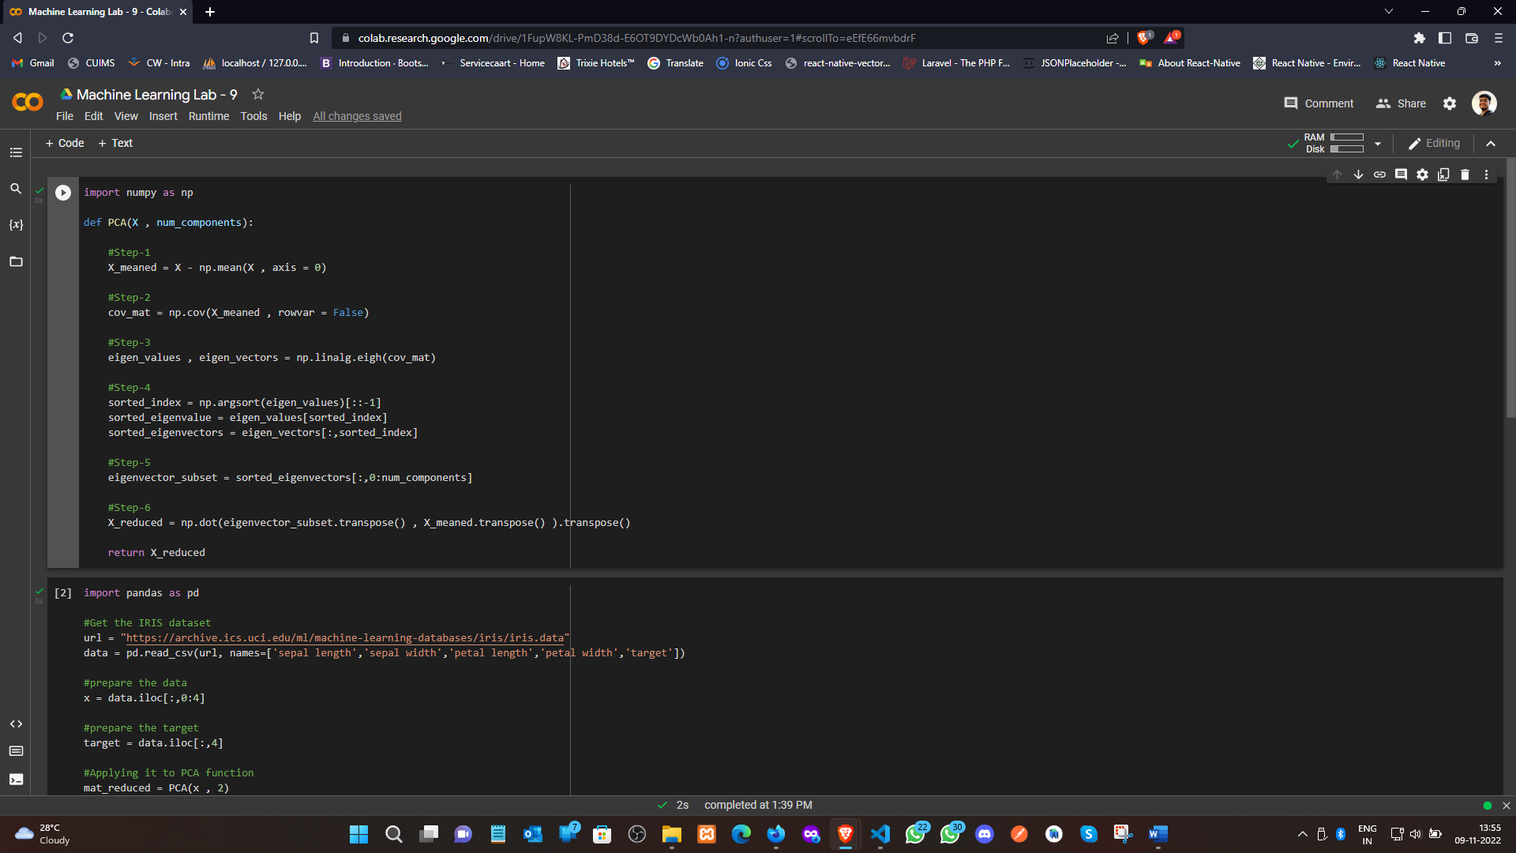

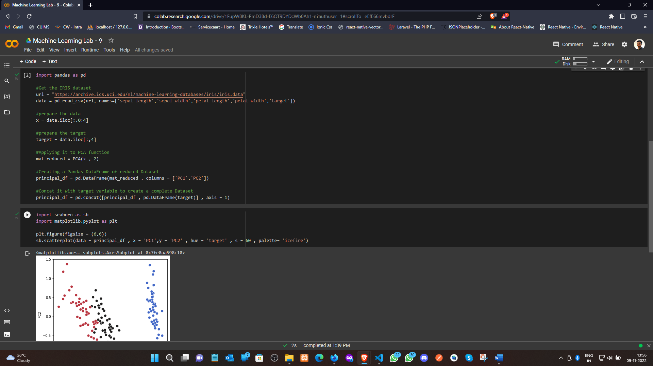

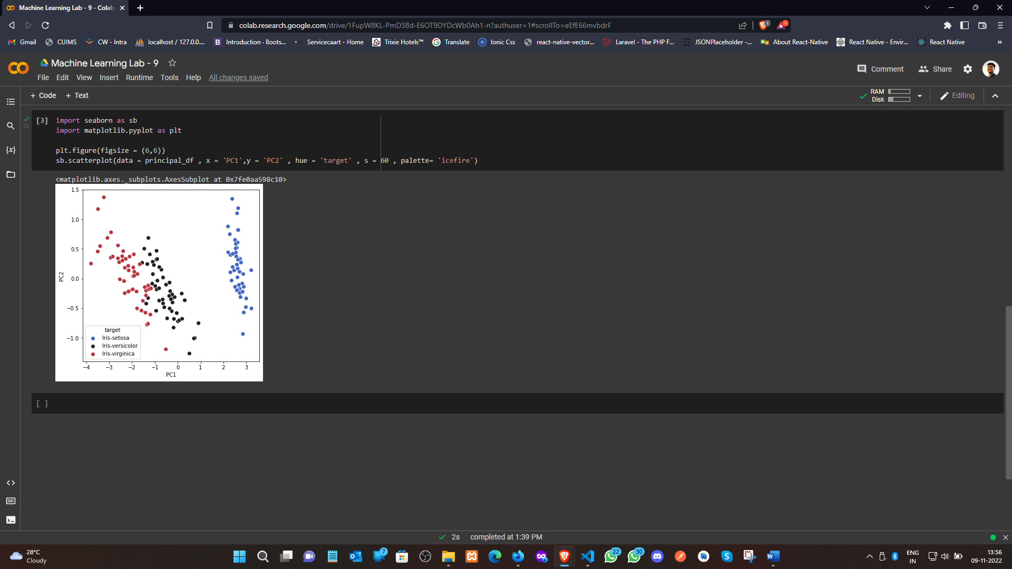

**Learning outcomes (What I have learnt):**

1. Understood the concept of PCA.
2. Learnt how to Covariance Matrix.
3. Learnt the separation of eigen value and eigen vectors from CM.
4. Plot the graph using seaborn and matplotlib.

**Evaluation Grid (To be created as per the SOP and Assessment guidelines by the faculty):**

|  |  |  |  |
| --- | --- | --- | --- |
| Sr. No. | Parameters | Marks Obtained | Maximum Marks |
| 1. |  |  |  |
| 2. |  |  |  |
| 3. |  |  |  |
|  |  |  |  |